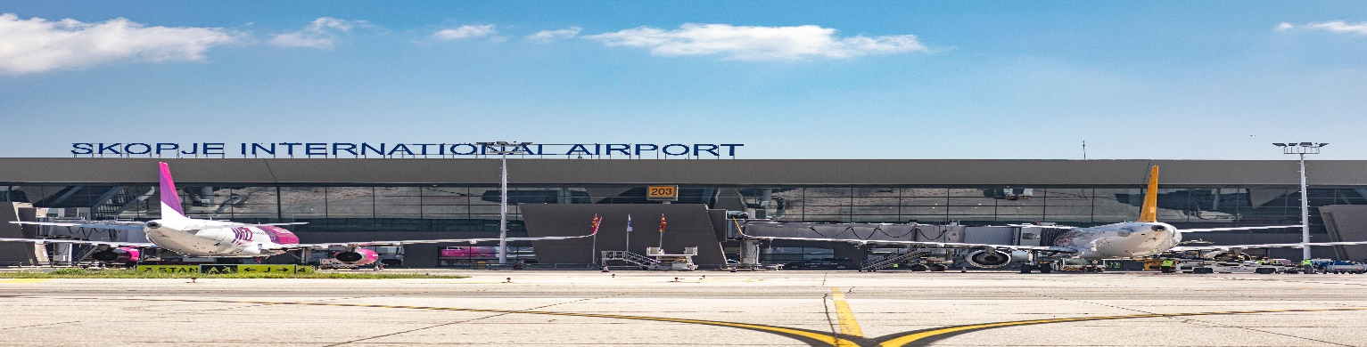
МЕЃУНАРОДЕН АЕРОДРОМ СКОПЈЕ
Skopje International Airport / Aeroporti Ndërkombëtar i Shkupit
email: customer.mk@tav.aero
Формулар за жалби / Complaints Form / Formulari i Ankesave

Complaints are concrete letters for dissatisfaction of airports services, in which passengers explain in details their airport experience, complaining on an exact matter, describing the situation with date and time, with the persons involved etc. Without these information the complaint shall not be taken into consideration.
Име / Name / Emri: __________________________________________________________________________________________
Презиме / Surname / Mbiemri: _____________________________________________________________________________
Датум / Date / Data: __________________________________________________________________________________________
Телефон / Phone no / Telefoni: _____________________________________________________________________________
Е-пошта / Email / Email: _____________________________________________________________________________________

Вашата жалба / Your complaint / Ankesa juaj
_________________________________________________________________________________________
_________________________________________________________________________________________
_________________________________________________________________________________________
_________________________________________________________________________________________
_________________________________________________________________________________________
Registered by: __________________________________________________________________________

